UPDATE KE VERSI 2023-11-28
Update file ZYA CBT
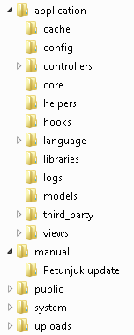
Setelah melakukan Extract file Aplikasi Ujian Online yang baru, replace folder berikut :
- application – config – config.php
- application – controllers
- application – models
- application – views
- application – third_party
- system

